
Sugar Terminals Limited
Lucinda Bulk Sugar Terminal
Jetty Pile and Headstock Remediation
Marine Access and Remediation Methodology
Document ED-018-2026-04 | Revision A | 16 August 2026
Draft for review
Prepared for | Sugar Terminals Limited
Prepared by | Endura Decommissioning (Van Iersel Projects Pty Ltd)
Engagement | Access Methodology Options Assessment, ref ED-018-2026-01
Companion document | ED-018-2026-05 Productivity Model, which carries the cycle build up and rate calculations summarised in Section 8
Status | Concept stage. Supplier selections, trial rates and the production programme are outstanding and are identified in Section 12

This document describes a method of working. It makes no assessment of the incumbent contractor or of any contractual position, and it contains no cost commitment. Comparisons are drawn between methods, on the same scope and the same definition of a completed bent.
Document control: internal development iterations were superseded before any issue outside Endura and are recorded in the author response register. This controlled track starts at Revision A by direction of S Kurien, 16 August 2026.

Contents
1 Introduction 3
2 Site and structure 3
3 Existing access method and performance 4
4 Proposed access system 4
5 Equipment 5
6 Work sequence at a typical bent 7
7 Campaign operation and access strategy 8
8 Productivity assessment 9
9 Marine logistics and site access 11
10 Safety in design and operations 11
11 Open items and verification 11
12 Recommendations and next steps 12

1 Introduction
Sugar Terminals Limited requires the priority integrity repairs on the Lucinda jetty to be complete by the end of 2028; the boundary of that priority scope is pending the bent register and, until it is received, the full remaining quantity of approximately 227 bents is used as a conservative stress case. The rate achieved to date will not meet the date on any reading. The dominant recoverable constraint in the current delivery arrangement sits in the serial access and workflow cycle, while repair quantities, approvals, coating windows and the marine calendar remain material drivers in their own right. Endura has been engaged to assess access methodology options and this document sets out the leading candidate: a marine based access system built around floating work platforms suspended from the headstocks, supported by a jack up barge and workboats, with conventional scaffold retained where the structure suits it.
The document describes the site and the constraint envelope, the present access arrangement and its performance, the proposed system and its equipment, the work sequence at a bent, the operation of the campaign along the jetty, and a productivity assessment comparing the two methods on a stated basis. Matters not yet established are marked in the text and collected in Section 11 with the means of closing each one. Where a figure is an estimate it is identified as one.

2 Site and structure
The jetty extends approximately 5.7 kilometres and is carried on repeating steel pilebents. A typical bent is a welded steel box headstock, approximately 7.9 metres long, on two tubular steel piles raked at one in four. The deck above carries a single lane roadway limited to 8 tonnes on one side and a sheeted conveyor gallery on the other. The tide runs from LAT at RL minus 0.300 to HAT at RL 3.660, a range of 3.96 metres, and the headstock soffit sits above the highest tide, so suspended equipment at the headstock works clear of the water. Only dimensions verified against the drawings are carried in this document; the remainder follow once the drawing register is issued.
The contract package contains 237 firm bents per Appendix D, being 212 typical, 13 anchor bents of types A and B, 10 passing bay variants and 2 specials at bents 275 and 281, together with 20 optional expansion joint bents. These are the original contract quantities; the quantities remaining at a current date come from the bent register. Underpass access, removal of existing visco elastic wrap bands from nine nominated piles ahead of the new jacket, and full pile wrapping occur as additional scope on top of these families. The remediation scope at each bent is inspection, abrasive blasting, weld repair, recoating and petrolatum wrapping of the tidal zone, under the coating requirements of drawing G01: preparation to Sa 2.5 with the first coat applied within four hours of blasting, stripe coats, a first coat wash and dry, and a recoat window of 14 hours to 14 days.
Constraint | Value | Consequence for access
Tidal range | 3.96 m | All work below mid tide is time limited from fixed access
Roadway | single lane, 8 t | Every load along the deck competes with terminal traffic
Shipping | 11 to 15 calls a year | Each call requires a make safe and interrupts the front
Wet season | site demobilises | About a third of each year is not worked
Environment | marine park waters | Blast media and coating waste are contained and tracked
Table 1: The constraint envelope.

3 Existing access method and performance
Under the present arrangement, scaffold is erected at each bent from the roadway, the bent is encapsulated, the trades work through in sequence, and the scaffold is stripped and re-erected at the next bent. Materials, plant and waste travel along the single lane. Work in the tidal zone waits for the water.
The contractor programme of June 2026 allows fourteen to fifteen days at a typical bent, with a median of fourteen days across its 257 bents. Within that allowance the programme itself assigns two days to scaffold erection, one to dismantling, three to a welding approval hold and two to Sundays, leaving roughly seven days of trade work in fifteen. To plan approximately 2.5 completed bents per production week (257 bents over the 104 production weeks left after 56.6 weeks of shutdowns), the programme carries up to nine bents in progress at the same time, while the inspection reports for the same period record four scaffold sets on the jetty. The programme runs from 3 November 2025 to 2 December 2028 around three wet season shutdowns of 125 to 136 days.
The claim records for March to July 2026 show approximately 0.36 safe access stage equivalents claimed per calendar week (7.9 equivalents over 21.9 weeks), with June the best month at 3.2. That figure is a payment stage quantity, not a count of completed bents, and it sits in different units on a different time base from the planned rate, so the two are not directly comparable and no percentage of plan is stated in this document. Read separately, the two figures still describe the position: the plan depends on many bents being in progress at once, and the claimed production is well short of what that plan needs. The July 2026 inspection reports record welders stood down for want of workable fronts while four scaffold sets stood on the jetty.
On this evidence the dominant recoverable constraint is the access cycle, not the trades. Any contractor erecting and stripping access at every bent, feeding one lane and waiting on the tide meets the same arithmetic, and additional scaffold adds standing plant faster than it adds output.

4 Proposed access system
The proposed system replaces built access with positioned access at the bents where geometry allows it, which is the large majority of the scope. Two floating modular platforms are deployed at each working bent, one against each long face of the headstock. Each platform carries its own electric winch units, and the winches run on sliding beam clamps fixed to the headstock so that the suspension can travel laterally as the raked piles move outboard with depth. The platforms are transferred off the JUB crane or floated in by workboat, hooked to the pre installed slings on clamps, and winched clear of the water. From that point the working deck holds a fixed relationship to the structure at any height from the headstock soffit to the waterline, and the tide no longer sets the schedule of the work above it.
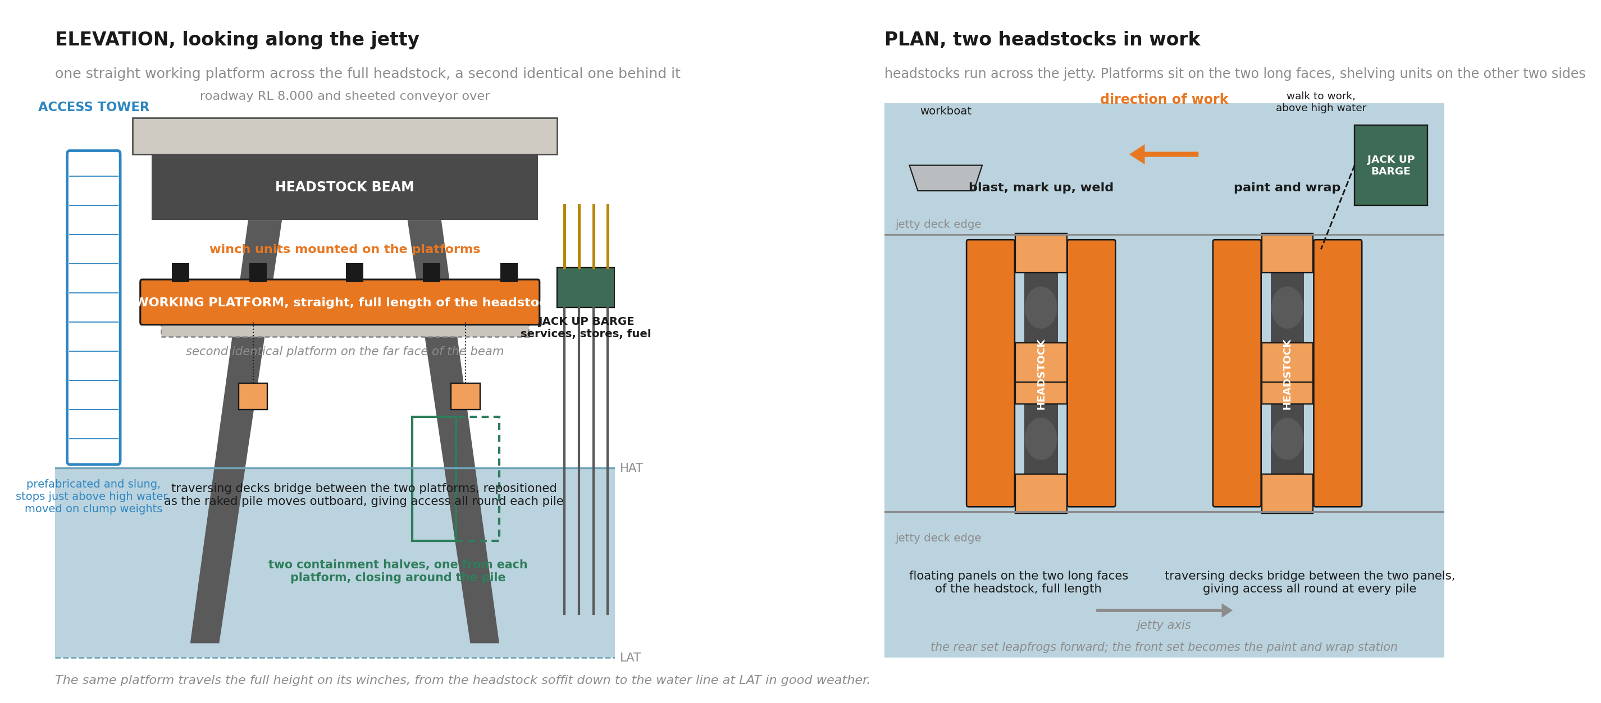
Figure 1: General arrangement at a typical bent. Elevation looking along the jetty, and plan with two headstocks in work.
Traversing decks span between the two platforms at each pile and are repositioned as the platforms travel, providing standing access around the full circumference of each pile at every working height. Containment is carried on the platforms as two half shells, one on each side, which close and bolt around the pile section being blasted and are opened and moved along as the work advances. An access stair tower hangs from the jetty deck edge on clump weights, and a jack up barge stands adjacent as the services base, carrying generators, compressors, breathing air, stores, fuel, waste and crew welfare, with a walk to work connection above the high water line.
The system is not proposed for every bent. Anchor bents carry bracing that may foul the platform envelope, and the specials have their own geometry. At those bents conventional scaffold, boat supported work or a hybrid of the two is retained. The objective of this methodology is production rate across the campaign, not uniformity of method, and the access strategy by bent family is set out in Section 7.

5 Equipment

5.1 Floating platforms and suspension
The platforms are modular floating pontoons, full length of the headstock, with handrails, integral electric winch units and lifting points. The winches operate together under one control so the platform rises and lowers level, and the sliding beam clamps carry the suspension laterally along the headstock flange. The lateral travel is a defining requirement of the system: the piles rake at one in four, so a platform descending four metres must track approximately one metre outboard to stay at the pile face without side loading its rigging. Suitable platform units have been identified in the region; none is selected.
To be established: Platform supplier data: module dimensions, bare and rigged mass, deck capacity, freeboard, winch type and control, lifting points, and the sliding clamp arrangement with travel range, locking and fault cases. The arrangement passes through temporary works design, independent check and an installed proof test before first use.

5.2 Traversing decks
The traversing decks are perpendicular panels spanning between the two main platforms, running on guides along the platform inner edges so that each deck can glide along the bent. As the platforms travel down and the raked piles move outboard, the decks slide along the guides to stay at the pile, which is what keeps access all round each pile at every height. They are the least defined element of the system and the productivity assessment takes no credit for them beyond a movement allowance: they carry personnel and must glide and lock reliably while maintaining edge protection and gap control at the pile.
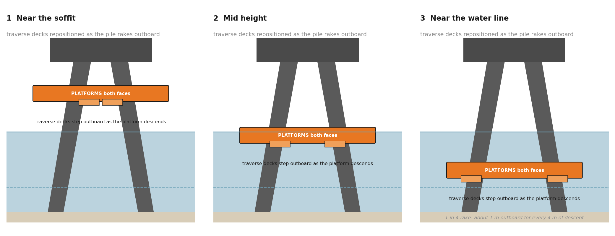
Figure 2: Traversing decks are repositioned as the platforms descend and the raked pile moves outboard.
To be established: Traversing deck design: dimensions, load path into both platforms, travel and locking arrangement, edge protection, dropped object protection over water, and the repositioning sequence with personnel on the decks.

5.3 Half shell containment
Each platform carries one half of a rigid containment shell. The halves close and bolt around the pile with wrap at the joints only, extraction draws the enclosure to negative pressure, and spent media and coating debris are recovered to sealed drums. The enclosure is reused along the whole jetty; nothing is built and destroyed at each bent. Because the shells close across two independently suspended platforms, the platforms are restrained and aligned to a stated tolerance before closure, with interlocks preventing closure outside tolerance, a wind limit and an emergency opening arrangement.
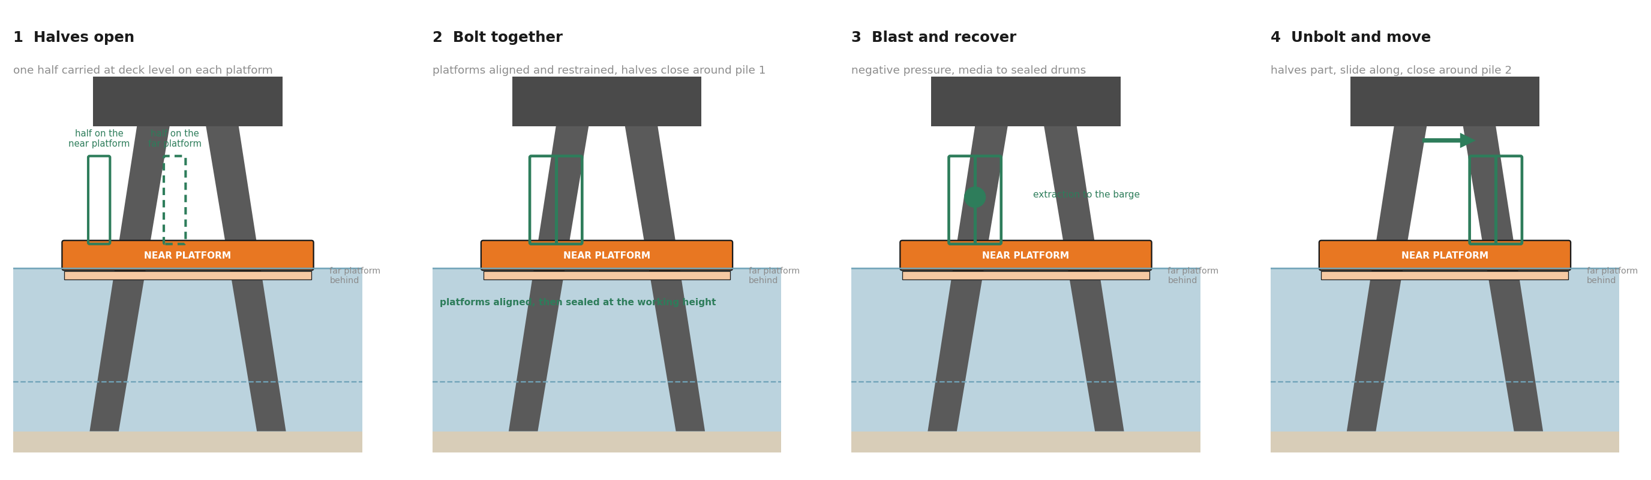
Figure 3: The half shells. One carried on each platform, bolted together around the pile, opened and moved to the next section.
To be established: Containment supplier and system: shell geometry and mass, seal at the pile and between halves, negative pressure and air changes, filtration, noise, the alignment and interlock arrangement, and whether a double height shell is within platform capacity.

5.4 Containment at the headstock
The shells fit a circular pile. The headstock itself, its long faces, its end faces, the pile connections, gallery feet and keeper angles need their own enclosure, most likely the same panel system re hung from the platforms to box the beam. No supplier arrangement exists yet and the productivity model shows this work as not modelled, not estimated.
To be established: Headstock containment arrangement: panel configuration, sealing at the soffit and the platform edges, extraction in the larger volume, access to every interface identified on the coating drawings, and the work content it adds to the bent cycle.

5.5 Below the waterline
The petrolatum jacket zone extends below LAT. Lowering the platform reaches the tidal band but not the submerged length, so the method for the below water portion, boat supported at low water, diver assisted, or a system change agreed with the jacket manufacturer, remains to be selected.
To be established: Jacket method below LAT: submerged length, lower termination, handling, tensioning, inspection and acceptance, reconciled against drawing G01 and the manufacturer data.

5.6 Access towers, barge and marine craft
Access towers are prefabricated, hung from the jetty deck edge on clump weights, and stop just above high water. The barge crane lifts each tower forward as the front advances, so no tower is ever rebuilt. The jack up barge is the services base and not a workface; it is to be shown capable of keeping power, air and extraction running while it repositions between production periods. Two craft are carried and kept distinct: a workboat for positioning platforms and moving materials, and a rescue craft that is crewed, on station whenever personnel are over water, and assigned no other duty.
To be established: Barge selection against bathymetry along the alignment, crane reach for tower moves at each bent family, the service umbilical arrangement for platforms that travel vertically and laterally, tower reactions and clump weights, and the cyclone recovery case sized against the full fleet.

6 Work sequence at a typical bent
A set is assembled, rigged and proof loaded onshore or on the barge deck before it approaches the structure. A rigging crew works one bent ahead of the platforms, installing and proof testing the beam clamps and hang off points and recovering the gear from completed bents; this is a resourced parallel work package and the productivity model carries an allowance for it.
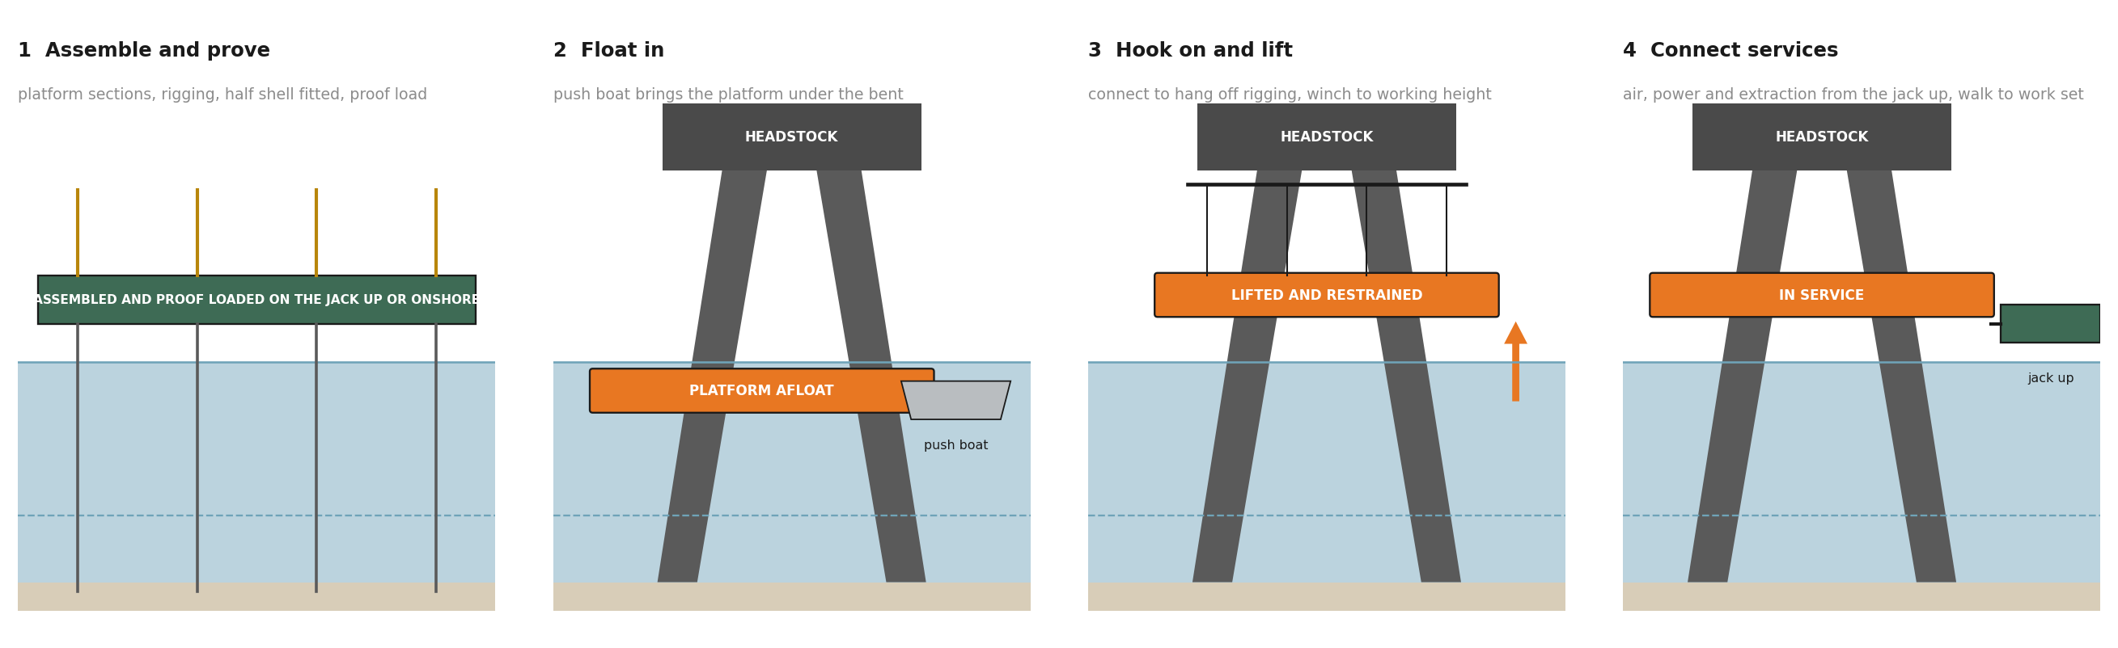
Figure 4: Deploying a set. Float in, hook on, lift and connect services.
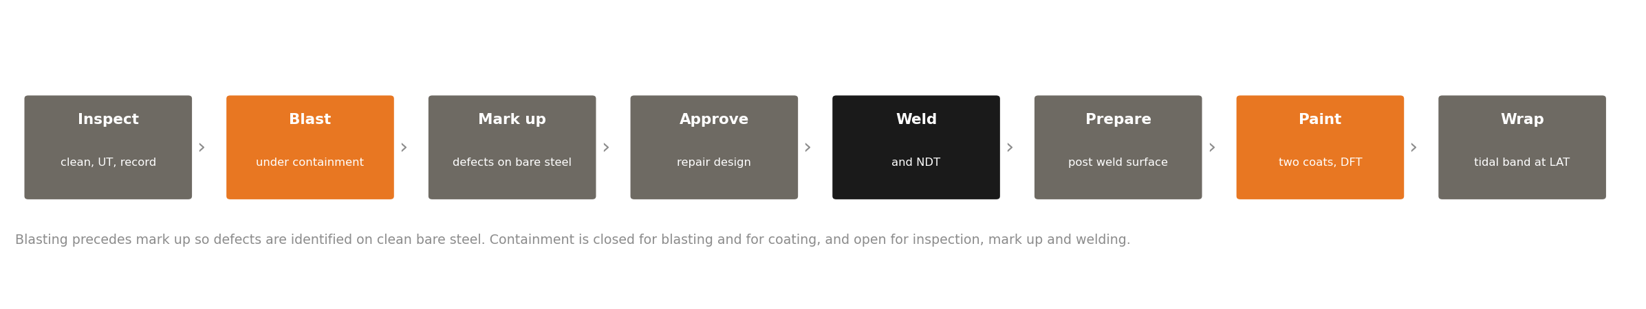
Figure 5: The work sequence at a pile.
6.1 Inspection. The platform is set at the upper working position. Existing wrapping is removed where required, the surface is washed, and thickness testing and visual inspection are recorded against the pile identification.
6.2 Diagnostic blasting. The half shells close around each zone in turn, both piles and the headstock faces, and each is blasted under negative pressure with media and debris recovered to sealed drums (one shift: the pile bands are about 27 to 29 of the 46 to 51 square metres at a bent, blasted at 8 to 12 square metres an hour). This first blast is diagnostic exposure to reveal the true condition of the steel; it is not the surface the coating is applied to.
6.3 Mark up. Defects are marked on clean bare steel across both piles and the headstock, establishing the repair extent and geometry for the whole bent. On the current works, defects have repeatedly emerged only after blasting, producing repairs found late and coating done twice; identifying the whole scope on bare steel reduces late discovery and allows a single approval submission.
6.4 Approval, once per bent. Because mark up covers both piles and the headstock, one bent level submission is made and one three day hold is carried (the hold the contract programme allows). The platforms remain rigged through the hold, so it costs occupancy at that bent; the campaign continues because the second set is working the adjacent headstock. A pre approved library of standard repair details, agreed with the reviewing engineer in advance, collapses this hold to exceptions only and is recommended in Section 12.
6.5 Weld repair and testing. Repair plates are fitted and welded to the approved details, and completed welds are tested. Rejected welds are rectified and re tested before the zone is released.
6.6 Final surface preparation. After welding at the pile, the whole coating zone of that pile, not only the weld and its heat affected zone, receives final preparation to Sa 2.5, either by full zone re blast or by a preservation method agreed in writing with the coating manufacturer. The elapsed time is carried in the cycle.
6.7 Coating. To drawing G01: environmental conditions are checked, the first coat is applied within the four hour window after final preparation, stripe coats are applied at welds, edges and fittings, the first coat is washed and thoroughly dried, and the second coat is applied inside the recoat window of 14 hours to 14 days. Film thickness and holiday checks are recorded per work lot. The recoat and drying steps are elapsed time and do not compress with shift count.
6.8 Wrapping. The platform lowers to the tidal band, the traversing decks reposition to suit the rake, and the petrolatum jacket is installed and verified over the specified zone.
After the single approval, repair and finishing run pile by pile: the first pile is taken through welding, final preparation, coating and wrap before the traversing decks, shells and crew move to the second pile, and the platforms remain at the bent throughout. The completed pile is then protected, with blast curtains and mechanical protection as required, while the second pile and the headstock are worked, and its finish is reinspected before the bent is offered for acceptance. Where hot work adjacent to an accepted finish cannot be adequately protected, that work is brought forward in the sequence ahead of the finish. A bent is complete when the welds, coating, wrap and records at both piles and the headstock are all accepted; stage quantities are not counted.

7 Campaign operation and access strategy
Two sets are described here to explain the operation; the campaign fleet is settled in Section 8. The sets operate together. The leading set carries out inspection, blasting, mark up and weld repair; the trailing set carries out final preparation, coating, wrapping and closeout. When the trailing set completes its bent it is released, lowered onto its floats and moved by workboat past the leading set to the next rigged bent, and the roles swap. The intent of the arrangement is that a hold or a curing period at one bent does not stop the campaign, because the other set continues; how often that is achieved in practice is measured in the production programme, not assumed here.
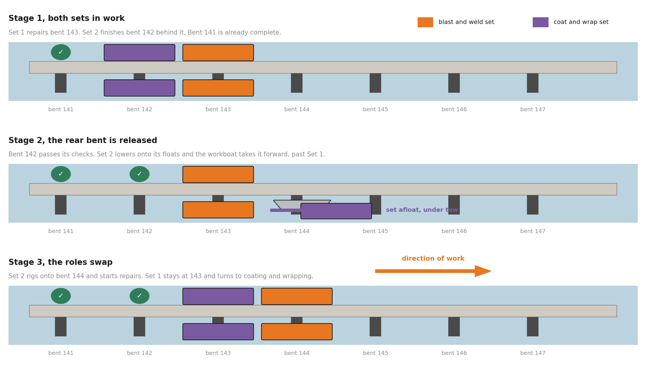
Figure 6: Two sets leapfrogging along the jetty. The rear bent is released, the set moves forward past the working set, and the roles swap.
The access method is chosen by bent family, with production rate as the objective; the method does not have to be uniform to achieve it.
Bent family, contract Appendix D | Count | Access method
Typical | 212 firm | Floating platform sets as described
Anchor bents, types A and B | 13 | Scaffold or hybrid; bracing may foul the platform envelope. Concept plate to confirm
Passing bay variants | 10 | Hybrid; wider deck above and different geometry below. Concept plate to confirm
Specials, bents 275 and 281 | 2 | Assessed individually; scaffold likely
Expansion joint | 20 optional | Floating sets with extended platforms, to be confirmed
Table 2: Access strategy by bent family. Underpass access, removal of existing visco elastic wrap bands (nine piles) and full pile wrapping overlay these families as attributes. The remaining mix at a current status date requires the bent register from STL.
Retaining scaffold where it suits the structure is deliberate. The productivity case rests on taking the 212 typical bents, the great majority of the scope, off the scaffold cycle; it does not require the floating system to fit every bent on the jetty.

8 Productivity assessment
The assessment compares the two methods at the level of the cycle at one typical bent, on the same completion definition. The required rate used throughout is 3.78 completed bents per week, the whole scope stress case of 227 bents over two nominal 30 week seasons (227 over 60), pending the priority boundary from the bent register. The current cycle is taken from the contractor programme. The proposed cycle is built activity by activity in the companion model ED-018-2026-05, on a single shift, with the weld content calculated from the repair quantities recorded to date: approximately 53 lineal metres per bent equivalent (473 lineal metres claimed across the inspected bents, most of it 10 millimetre plate), at two crews per bent and an accepted rate of 6 lineal metres per crew shift, values that sit at the defensible end of the range until trials prove better.
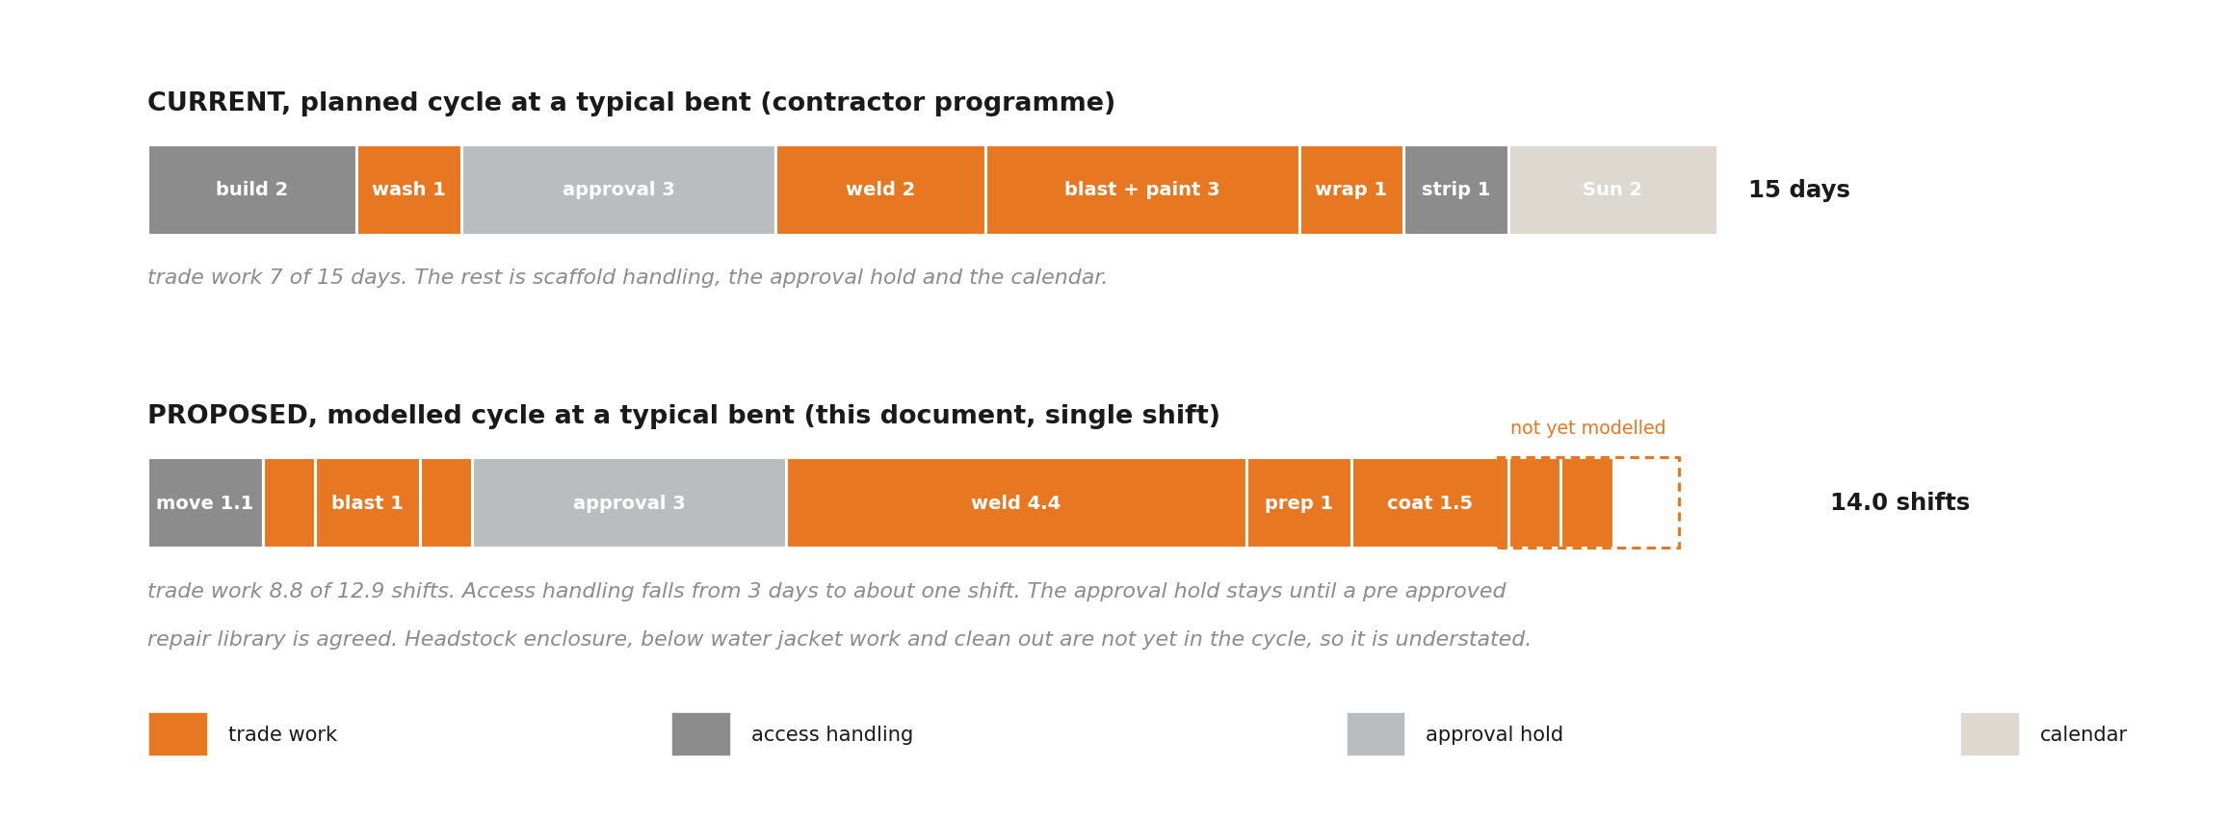
Figure 7: Where the time goes at one typical bent. Current planned cycle above, proposed modelled cycle below. Both bars are active work and hold shifts; the coating drying and recoat holds are additional elapsed time in both methods.
Three elements come out of the cycle under the proposed system. Scaffold erection and dismantling, three days at every bent, is replaced by a platform relocation of about one shift. The tidal waiting embedded in fixed access is largely removed above the waterline, because the platform travels to the work; the tidal band wrap and any below water work remain tide dependent. And the encapsulation is repositioned, not rebuilt. The three day approval hold remains in full, and the coating windows are elapsed time that no shift pattern compresses. The 14.0 day figure is active work and hold shifts (12.9 plus 1.1 for relocation), not a demonstrated elapsed cycle: the headstock enclosure, the below water jacket length, containment clean out and the coating drying and recoat holds are not yet modelled, so the proposed cycle is understated and the rates calculated from it are optimistic to that extent.
Welding is the largest modelled item in the proposed cycle, 4.4 shifts of the 14.0 day total (53 metres at two crews by 6 metres per crew shift), and the likely pacing trade once access ceases to govern. It cannot be confirmed as the governing constraint until the unmodelled activities are added. What can be stated is the shape of the result: the rate scales with the number of sets deployed, because each set carries its own access and containment, and it scales with weld capacity, because welding dominates the modelled content. Neither of those statements is true of the current method, where each additional front requires another scaffold cycle on the same lane.
Worked example, two sets on the modelled cycle: 2 sets by 6 working days a week, divided by the 14.0 day cycle, by 85 per cent availability, equals 0.73 completed bents a week, calculated in ED-018-2026-05.
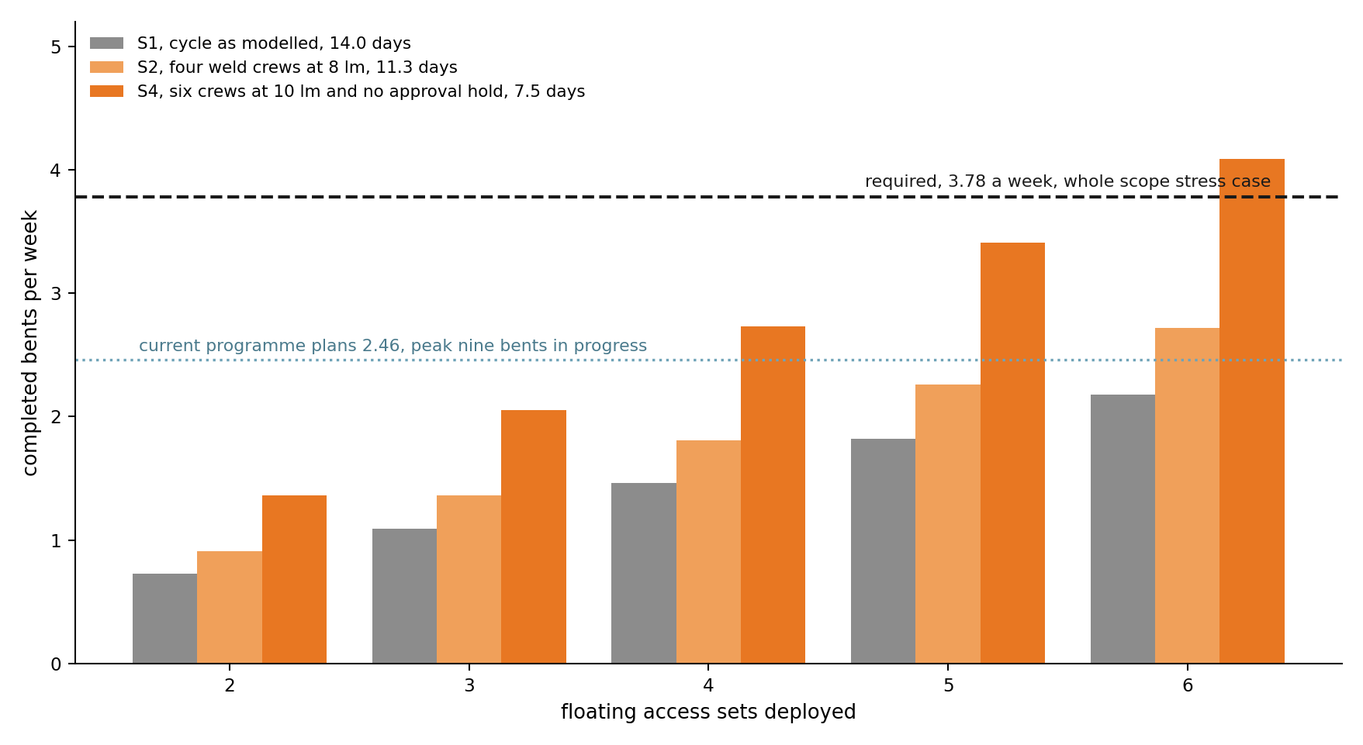
Figure 8: Completed bents per week against sets deployed, generated from the model. S3 sits between the two upper series; all four scenarios are computed in the companion model. Rate equals sets by 6 days over the cycle, by 85 per cent.
Case | Basis, one convention: relocation and availability carried in every case | Cycle, days | What must be proven
S1 | As modelled: 2 weld crews at 6 lm per crew shift, full approval hold | 14.0 | The base case; reaches 3.78 only at an impractical eleven sets
S2 | 4 weld crews per bent at 8 lm per crew shift | 11.3 | Safe concurrent weld zones, power, fume extraction, testing and supervision; needs nine sets
S3 | S2 plus a pre approved repair library removing the hold | 8.3 | The library agreed with the reviewing engineer; needs seven sets
S4 | 6 crews at 10 lm per crew shift, hold removed | 7.5 | Trial proven rates over full shifts including rework; reaches 3.78 at six sets
Table 3: Improvement scenarios computed in the companion model on one convention. Sets needed equals 3.78 times the cycle divided by 6 days at 85 per cent availability, rounded up. Illustrative, not commitments: the unmodelled items will lengthen every cycle above, and the fleet is settled by the completed production model, not chosen here.
On this convention the required rate is reached only in the strongest scenario with six access sets, before the headstock enclosure, the below water jacket and clean out are added to the cycle. That is stated plainly because it is the finding that sizes the fleet, and it is the reason the fleet is settled by the completed model and not chosen today. No productivity ratio against the claimed performance of the current works is stated, because the claimed figures are payment stage quantities in different units on a different time base. The comparison that can be made honestly is the one above: cycle against cycle, on the same completion definition, with every assumption visible and the gaps named.

9 Marine logistics and site access
Personnel arrive by minibus, cross to the structure by the access towers or the walk to work, and remain at the workface for the shift, with the meal break taken on the barge. Generators, compressors, breathing air, coating stores, fuel and consumables are staged on the barge and fed to the platforms by service lines; materials and sealed waste move by water. The roadway carries people and light duties only and is otherwise returned to terminal operations. The barge relocates between production periods, not during them, an intent to be demonstrated with a staging plan showing the bents served from each set up.
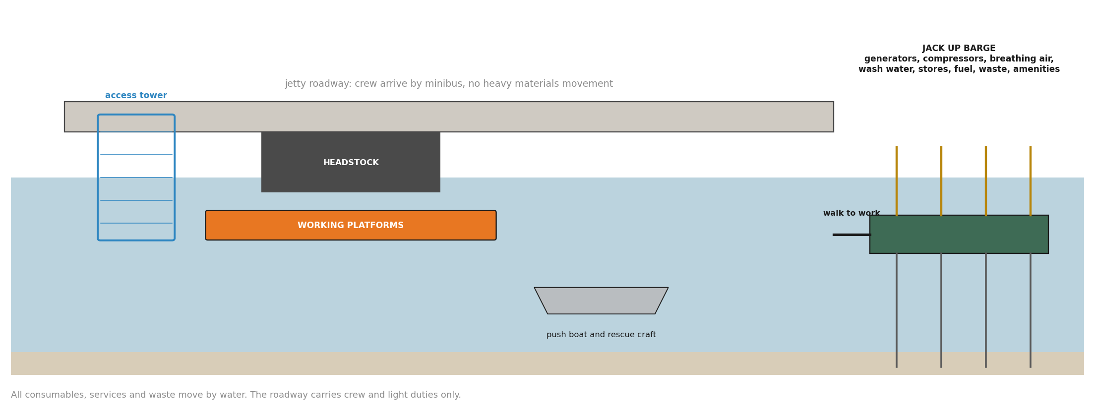
Figure 9: The logistics arrangement. Services and materials by water, crew by road, the roadway kept clear.

10 Safety in design and operations
Suspended marine access brings its own requirements and they are written here as acceptance requirements, to be demonstrated before production, not as established capabilities. Two independent means of egress or recovery must be demonstrated at every operating elevation; the access tower terminates above high water while the platform travels below it, so the normal egress geometry changes with elevation and each state is proven, not assumed. Controlled lowering on loss of power must be confirmed by the winch and control supplier. A stretcher path from every working level, including from inside a closed containment, is proven by layout and by drill. Concurrent hot work, blasting and coating are separated by a simultaneous operations matrix with wind direction rules, and exclusion zones apply beneath suspended loads and along boat routes.
The platforms carry limited freeboard when afloat, of the order of 150 millimetres on the units identified from supplier advice, unconfirmed, so the lowest working position is weather limited; a marginal sea state is answered by winching up and continuing at height, not by working at the waterline. Ship calls are managed by a defined make safe sequence for platforms, containment, services and craft within the notice period. Cyclone response is a feasibility gate: the full spread must be recoverable to the barge and the barge to its nominated refuge within the warning period, demonstrated by a timed drill before the fleet is expanded.

11 Open items and verification
The following are open at the date of this document. None prevents assessment of the method; all of them precede commitment to it.
Item | How it closes
Platform, winch and sliding clamp data | Supplier data sheets and pricing, requested
Traversing deck design | Supplier and temporary works deliverable; no rate credit until designed
Half shell system, alignment and interlocks | Supplier engagement, then trial
Headstock containment arrangement | Supplier concept, then a measured cycle
Jacket method below LAT | Manufacturer and marine specialist
Accepted weld rate | Timed trials over full shifts, including rework
Safe concurrent weld zones per bent | Workface layout with power, fume, testing and supervision
Fleet at full production | Completed cycle plus trial rates in a dated line of balance
Remaining scope by bent and family | As at date bent register from STL, requested
Barge suitability and cyclone recovery | Bathymetry, staging plan and a timed drill
Table 4: Open items and the means of closing each. Quantitative entries are populated by S Kurien as supplier data sheets are received.
The first bents are run as a proving campaign against acceptance criteria fixed in advance: relocation time for a set, containment close and move time, accepted weld rate over full shifts, the coating cycle inside the enclosure, concurrent operations demonstrated safe, and a timed rescue and recovery drill. The trials populate the production model. A completed model, covering every bent family on a dated calendar with the fleet costed, is the gate before any completion rate is committed or any procurement recommendation is made.

12 Recommendations and next steps
Endura recommends the following next steps.
12.1 Establish a pre approved repair library. The three day approval hold is the largest single recoverable block in either cycle. A library of standard repair details by defect class, agreed with the reviewing engineer before the campaign, collapses the hold to exceptions only. It is the largest single recoverable block identified so far in either cycle.
12.2 Run an advance inspection front. Ultrasonic thickness screening from boat and rope access, one season ahead of the repair front, ranks the bents, pre sizes repair plates and feeds the library, so that the repair scope at each bent is substantially known before the platforms arrive.
12.3 Agree a current bent register and a single completion definition between STL and the delivery team, so the remaining scope, the family mix and the measure of progress are settled before the production programme is built.
12.4 Issue the supplier enquiries for the floating platforms, the containment system and the jack up barge, and confirm bathymetry along the alignment. These are the long lead items and nothing else waits on them.
12.5 Trial the weld workface. Establish the number of concurrent weld zones a bent safely supports, and the accepted rate per crew shift over full shifts including rework, on the first bents. These two numbers size the fleet and the workforce.
12.6 Use the wet season deliberately: offsite fabrication of repair plates from the advance inspection data, refurbishment of shells and rigging, and pre kitting of the next season's bents, so each shutdown feeds the season that follows.
The concept is put forward because it removes the access constraint that scaffold expenditure cannot, and the constraints it leaves behind, welding capacity and fleet size, respond to resourcing. Whether it delivers the required rate is settled by supplier development and the proving campaign, and the pack is arranged so that either answer shows early, on the structure, before the programme is committed.

